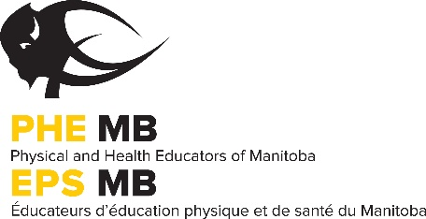
PROFESSIONAL DEVELOPMENT FUND POST-EVENT REPORT

PLEASE INCLUDE THE FOLLOWING WITH THIS REPORT:
- Receipts of expenses incurred from the conference/workshop.
- An article describing the conference, workshop or sessions attended for publication in the PHE Manitoba Journal. Please include some practical games, innovative ideas and/or different activities to share with your colleagues. Be sure to include the details to allow others to replicate the game, idea and/or activity!

Name: ______________________________ Mailing Address: _____________________________
City: __________________________________ Postal Code: _______________________________
Phone (w): __________________________ Email: _____________________________________
School: _____________________________ Division:___________________________________
___Yes, I would be willing to share my experience with my colleagues at a workshop.

Workshop/Conference

Location

Dates Attended

PHE Manitoba PD Funding Contribution $
EXPENSES
Registration Fee $
Lodging $
Transportation $
Substitutes $
Food $

TOTAL $

***COPIES OF ALL NECESSARY RECEIPTS MUST BE ATTACHED FOR THE APPLICATION TO BE PROCESSED. EMAIL YOUR PHE Manitoba JOURNAL ARTICLE TO phemb@sportmanitoba.ca***
Article and receipts must be submitted to the PHE Manitoba office by June 23rd, 2024, to receive funding. Late submissions will not be accepted.

Please send completed post-event forms to:
PHE Manitoba, 319-145 Pacific Avenue, Winnipeg, MB R3B 2Z6
Email: phemb@sportmanitoba.ca

